
COMT – GROUP ASSIGNMENT
TECHNOLOGY PARK MALAYSIA
042026-FHI
COMPUTING THEORY
INTAKE CODE: APU2F2511CS(CYB)
LECTURER NAME: Ms. Farhana Illiani binti Hassan
COMT (CT111-3-2)
HANDOUT DATE: WEEK 4
COMPLETION DATE: WEEK 13
CHOSEN CASE STUDY: PARKEASY SMART PARKING SYSTEM
NAME | TP NUMBER
SUDHAARSHAN NAIR A/L GOPALAN | TP077292
DANISH AIMAN BIN ROSHADLISHAM | TP077272
AHMAD NUR AZAMI AMZAR BIN NIZAR | TP077269
IDDIN IRFAN MIKHAIL BIN NOOR IZWAAN | TP077270

Table of Contents
Table of Contents 2
Non-Deterministic Automata Diagram 3
Diagram Explanation 4
Diagram Justification 5
Accepted String Tracing 6
Rejected String Tracing 7
Quintuple 8
State Transition Table 8
Regular Expression 9
Step-by-step derivation 9
Final Regular Expression 15
Verification 16
Complexity 17
Best-Case Time Complexity 18
Worse-Case Time Complexity 18
Why a DFA Cannot Exceed O(n) 20
Summary 20
Computability Properties of the Language L 20
Workload Matrix 23
References 23

Non-Deterministic Automata Diagram
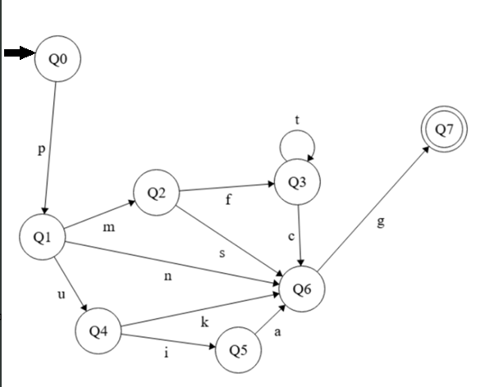
Symbol | Elaboration
p | - Vehicle approaching exit barrier  - LPR camera capture license plate
m | - License plate matches to registered account  - Auto-deduct enabled
s | - Auto-deduct successful
f | - Auto-deduct fails
c | - Manual payment completed
t | - Manual payment timeout passed 90 seconds
u | - License plate does not match any account or misread
k | - Valid ticket number
i | - Invalid ticket number
a | - Attendant-assisted procedure
n | - Season pass detected
g | - Sensor confirms vehicle exited the barrier

States | Elaboration
Q0 | - Idle state
Q1 | - License plate captured
Q2 | - Processing auto-deduct
Q3 | - Pending manual payment using kiosk
Q4 | - Pending ticket entry
Q5 | - Attendant-assisted mode
Q6 | - Barrier is lifted
Q7 | - Barrier is lowered

Diagram Explanation
This Finite Automata provides a visualization of one complete transaction of the exit barrier in the parking system. From the start state (q0), the exit barrier is in an idle state, before the arrival of a vehicle moves the system to the next state (q1). In this state, the LPR branches three ways. The first direction would be if the license plate of the vehicle is matched to a registered account, the system moves to q2. This particular state has a branch where the direction of the system depends on whether the auto-deduction process is successful or has failed. If the process is a failure, the system moves into q3, where the user has a 90-second kiosk window to deliver manual payment, which if the user surpasses the time limit, an alert will be raised in a repeated manner while the barrier remains closed. Once the payment has been made, the system will move to q6 where the barrier will be lifted. On the other hand, if the auto-deduction is a success, the system will move to q6 indefinitely and the barrier is lifted. Now in the scenario in which the license plate is not registered or is misread, the system will move to q4 where the user must manually insert their ticket number details in 20 seconds, before branching out in two states depending on the validity of the ticket. If the ticket is valid, the system moves to q6 and barrier is lifted. If the ticket is invalid, the system moves to q5 where the attendant will assist the user before moving to q6. The q6 state represents the lifting of the barrier, which is reached after any legitimate payment method has been made. The system then moves to the accept state (q7), where the barrier is lowered.

Diagram Justification
After careful consideration and analysis, we concluded that the best finite automata that is optimal for this case study is the NFA. While a Deterministic Finite Automaton (DFA) can provide strict predictability, an NFA is chosen to model the ParkEasy Smart Parking System for the following reasons.
Justification | Explanation
Reduce Complexity | - Using our 11-symbol input alphabet, a DFA requires transitions for every symbol at every state, causing an increase in complexity with multiple trap states.  - NFA allows partial transition functions, rejecting undefined symbol paths.  - Keeps diagram clean and focused on the logic of the scenario
Parallel Hardware Events | - The hardware components of this system work asynchronously, such as the LPR cameras and manual kiosk bring triggered independently  - NFA models system environments where the system can inhabit possible states simultaneously.  - Manual payment being made at the exact moment the 90-second timeout fires
Modularity | - Real-world software architectures such as the ParkEasy system follows a modular approach.  - The payment subsystem works separately from the barrier subsystem.  - Adding new feature in the future only requires adding a parallel path, instead of completely recalculating the states with a DFA.

Accepted String Tracing
The example of an accepted string that we will use here would be ‘pmsg’.
In this string, the vehicle first approaches the exit barrier. The LPR then matches the license plate of the vehicle to a registered account and proceeds to the auto-deduction process. The process is then successful, to which triggers the barrier to be lifted and lowered once the vehicle exits.

Step | Input | Current State | Next State
1 | p | Q0 | Q1
2 | m | Q1 | Q2
3 | s | Q2 | Q6
4 | g | Q6 | Q7

Rejected String Tracing
The rejected string that will be used here would be ‘pmft’.
In this scenario, the vehicle approaches the exit barrier and the LPR detects a registered account based on the license plate. The system proceeds to the auto-deduction process. However, the process is failed, and manual payment must be done. Failure to input their payment within the 90-second mark would result in the alert being raised repeatedly while the barrier remains closed, which would result in the system never reaching the accept state where the barrier would be lifted.
Step | Input | Current State | Next State
1 | p | Q0 | Q1
2 | m | Q1 | Q2
3 | f | Q2 | Q3
4 | t | Q3 | Q3

Quintuple
The ParkEasy exit barrier system is formally defined as a Non-Deterministic Finite Automation (NFA), represented as a Quintuple:
M=(Q,Σ,δ,q0​,F)
Q = {Q0, Q1 ,Q2, Q3 ,Q4, Q5, Q6, Q7}
Σ = {p,m,s,f,c,t,u,k,i,a,n,g}
δ = {Q x Σ > Q}
q0 = Q0 (idle state)
F = {Q7}

State Transition Table
$$δ$$ | a | c | f | g | i | k | m | n | p | s | t | u
Q0 | $$∅$$ | $$∅$$ | $$∅$$ | $$∅$$ | $$∅$$ | $$∅$$ | $$∅$$ | $$∅$$ | Q1 | $$∅$$ | $$∅$$ | $$∅$$
Q1 | $$∅$$ | $$∅$$ | $$∅$$ | $$∅$$ | $$∅$$ | $$∅$$ | Q2 | Q6 | $$∅$$ | $$∅$$ | Q4 | $$∅$$
Q2 | $$∅$$ | $$∅$$ | Q3 | $$∅$$ | $$∅$$ | $$∅$$ | $$∅$$ | $$∅$$ | Q5 | $$∅$$ | $$∅$$ | $$∅$$
Q3 | $$∅$$ | Q6 | $$∅$$ | $$∅$$ | $$∅$$ | $$∅$$ | $$∅$$ | $$∅$$ | $$∅$$ | Q3 | $$∅$$ | $$∅$$
Q4 | $$∅$$ | $$∅$$ | $$∅$$ | $$∅$$ | Q5 | Q6 | $$∅$$ | $$∅$$ | $$∅$$ | $$∅$$ | $$∅$$ | $$∅$$
Q5 | Q6 | $$∅$$ | $$∅$$ | $$∅$$ | $$∅$$ | $$∅$$ | $$∅$$ | $$∅$$ | $$∅$$ | $$∅$$ | $$∅$$ | $$∅$$
Q6 | $$∅$$ | $$∅$$ | $$∅$$ | Q7 | $$∅$$ | $$∅$$ | $$∅$$ | $$∅$$ | $$∅$$ | $$∅$$ | $$∅$$ | $$∅$$
Q7 | $$∅$$ | $$∅$$ | $$∅$$ | $$∅$$ | $$∅$$ | $$∅$$ | $$∅$$ | $$∅$$ | $$∅$$ | $$∅$$ | $$∅$$ | $$∅$$

Regular Expression

Step-by-step derivation
Step 1: Add a new Initial State (s) and Accept State (A)
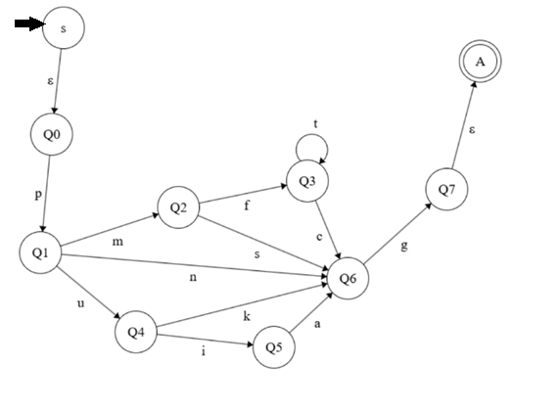
Step 2: Eliminate Q3
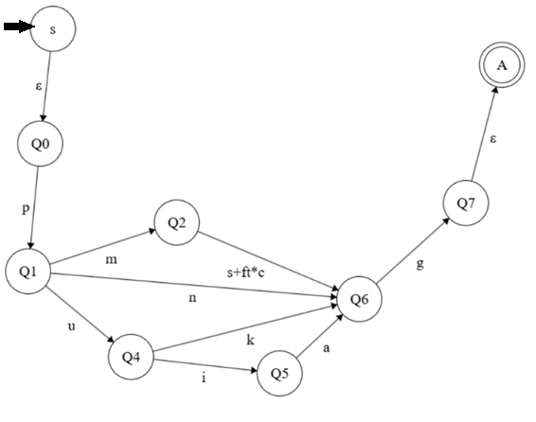
Eliminated state | Incoming transition | Outgoing transition | New transition
Q3 | Q2 –f→ Q3 | Q3 –c→ Q6  self-loop: Q3 –t→ Q3 | Q2 –(ft*c)→ Q6, combined with existing Q2 –s→ Q6, giving Q2 –(s + ft*c)→ Q6

Step 3: Eliminate Q5
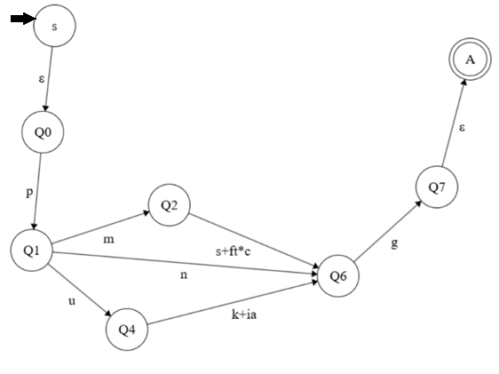
Eliminated state | Incoming transition | Outgoing transition | New transition
Q5 | Q4 –i→ Q5 | Q5 –a→ Q6 | Q4 –(ia)→ Q6, combined with existing Q4 –k→ Q6, giving Q4 –(k + ia)→ Q6

Step 4: Eliminate Q4
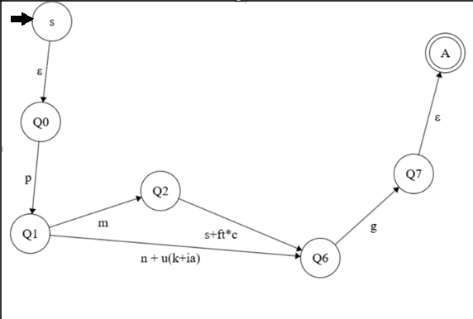
Eliminated state | Incoming transition | Outgoing transition | New transition
Q4 | Q1 –U→ Q4 | Q4 –(k+ia)→ Q6 | Q1 –u(k + ia)→ Q6, combined with existing Q1 –n→ Q6, giving Q1 –n+u(k + ia)→ Q6

Step 5: Eliminate Q2
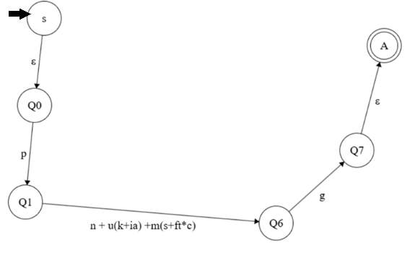
Eliminated state | Incoming transition | Outgoing transition | New transition
Q2 | Q1 –m→ Q2 | Q2 –(s+ft*c)→ Q6 | Q1 m(s+ft*c)→ Q6, combined with existing Q1 –n+u(k+ia)→ Q6, giving Q1 –n+u(k + ia)+m(s+ft*c)→ Q6

Step 6: Eliminate Q1
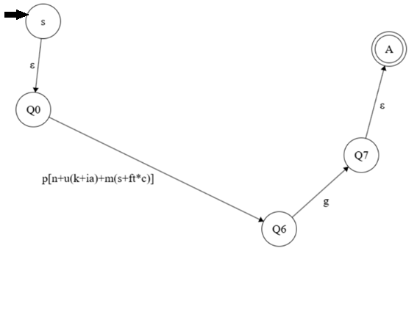
Eliminated state | Incoming transition | Outgoing transition | New transition
Q1 | Q0 –p→ Q1 | Q1 –[n+u(k+ia)+m(s+ft*c)]→ Q6 | Q0 –p[n + u(k+i·a) + m(s+f·t*·c)]→ Q6

Step 7: Eliminate Q6
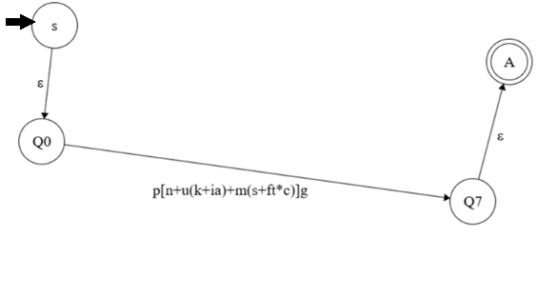
Eliminated state | Incoming transition | Outgoing transition | New transition
Q6 | Q0 –p[n + u(k+i·a) + m(s+f·t*·c)]→ Q6 | Q6 –g→ Q7 | Q0 –p[n + u(k+i·a) + m(s+f·t*·c)]g→ Q7

Step 8: Eliminate Q0 and Q7
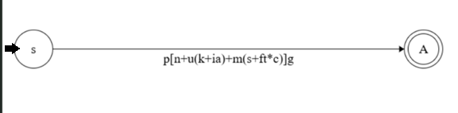

Final Regular Expression
The transition from the new initial state s to the new final state A gives a final Regular Expression, which is:
R=p[n+u(k+i⋅a)+m(s+f⋅t∗⋅c)]g

Verification
The generated Regular expression is verified using sample input string and a string will only be accepted if it matches the regular expression generated and ends at the accept state.
String 1: pmsg (Accepted)
State Trace
Q0 –p→ Q1 –m→ Q2 –s→ Q6 –g→ Q7
Result: Accepted
Reason: The string matches the sub-expression m(s+ft*c) using the s branch and terminates at accept state Q7.
String 2: pmft (Rejected)
State Trace
Q0 –p→ Q1 –m→ Q2 –f→ Q3 –t→ Q3
Result: Rejected
Reason: The string ends at Q3 which is not an accept state and does not satisfy the full pattern ft*c because the closing symbols (g) is missing. This means that the driver has not completed manual payment process.
String 3: png (Accepted)
State Trace
Q0 –p→ Q1 –n→ Q6 –g→ Q7
Result: Accepted
Reason: The string matches the n, which symbolises that the season pass is detected, bypassing both auto-deduct and unmatched plate sub-expressions, and later terminates at Q7, which is an accepted state.

Complexity
This section analyses the time complexity if ParkEasy DFA by examining the minimum and maximum number of state transitions required to process an input string of length n. A DFA should read each input symbol exactly once from left to right with no backtracking and the total number of transitions is always directly proportional to the length of the input string.

Best-Case Time Complexity
Best-Case Complexity: O(1)
The best case occurs when the FA rejects the input string after reading only the very first symbol. In the ParkEasy DFA, the start state Q0 has exactly one valid transition:
δ(Q0, p) = Q1
This means the only valid first symbol is p, which represents the LPR camera capturing the vehicle’s license plate. If any other symbol is received as the first input, such as m, f, t, or any other symbol in Σ, the FA immediately transitions to a dead state and rejects the string. No further symbols are read.
Since the FA terminates after exactly one step regardless of the total length of the input string, the number of transitions does not grow with n. This results in constant time complexity O(1).

Example string: “m”
In this example, the string begins with m, which is not a valid transition from Q0. The FA immediately enters a dead state and rejects the string after only one step.
Step | Input | Current State | Next State
1 | m | Q0 | Dead State

As shown above, only one transition occurs before the FA halts. Even if the string were “mpmftttcg’ at length 9, the FA would still rehect after the furst step, confirming constant time complexity O(1).

Worse-Case Time Complexity
Worse-Case Complexity: O(n)
The owse case occurs when the FA must read every single symbol in the input string before arriving at a decision. This happens along the longest possible path in the ParkEasy DFA, which involves the timeout loop at state Q3.
In Q3, the symbol t (manual payment timeout) causes the FA to loop back to Q3 itself:
δ(Q3, t) = Q3
This self-loop means that if a driver repeatedly fails to pay ithin the timeout window, the FA remains in Q3 and continues reading timeout symbols. The FA can only exit Q3 when it read c (successful manual payment), which then process to Q6 and finally Q7. This means every symbol in the string must be processed before a decision is reached.
Since each symbol is read exactly once and the number of steps equals the length of the input string n, this results in linear time complexity O(n).
Example String: “pmftttcg” (n=8)
In this example, the vehicle approaches the barrier, the plate is matched to a registered account, but the auto-deduct fail. The driver then experiences three consecutive timouts at the kiosk before successfully completing manual payment. The FA must read all 8 symbols before accepting.

Step | Input | Current State | Next State | Remark
1 | p | Q0 | Q1 | Plate captured
2 | m | Q1 | Q2 | Matched to account
3 | f | Q2 | Q3 | Auto-deduct failed
4 | t | Q3 | Q3 | Timeout loop 1
5 | t | Q3 | Q3 | Timeout loop 2
6 | t | Q3 | Q3 | Timeout loop 3
7 | c | Q3 | Q6 | Manual payment success
8 | g | Q6 | Q7 | Vehicle Cleared –  ACCEPT
As shown above, all symbols are read before the FA reaches the accepting state Q7. If the string contained 100 timeout symbols of transitions grows linearly with n, confirming O(n) worst-case complexity.

Why a DFA Cannot Exceed O(n)
It is important to note that O(n) is not just the worst case for this specific DFA which it is the upper bound for ALL deterministic finite automata. This is because a DFA processes each input symbol exactly once, in a single left-to-right pass, with no backtracking, no revisiting of symbols, and no branching. Therefore, for any input string of length n, a DFA will always perform at most n transitions, making O(n) the theoretical maximum complexity for any DFA regardless of its design.

Summary
 | Best Case | Worse Case
Complexity | O(1) | O(n)
Example String | “m” | “pmftttcg”
Steps | 1 | n (8 in example)
Reason | Invalid first symbol, instant reject | t loop forces reading every symbol
Path | Q0 > ∅ | Q0 > Q1 > Q2 > Q3 > Q4 > Q5 > Q6 > Q7

Computability Properties of the Language L
The language L accepted by ParkEasy exit barrier finite automaton is decidable because it is represented by a Non-Deterministic Finite Automaton (NFA) and Turing acceptable. The ParkEasy NFA consists of a finite set of states which are Q = {Q0, Q1, Q2, Q3, Q4, Q5, Q6, Q7}, an input alphabet Σ, a transition function δ, an initial state Q0, and an accepting state Q7. An algorithm can simulate the NFA by tracking all possible states after reading each input symbol. After the entire input is processed, the algorithm checks whether any possible path reaches Q7. If yes, the string is accepted; otherwise, it is rejected. Since the number of input symbols and states is finite, this process will always terminate. Because of this, a Turing Machine can simulate this NFA computation and determine whether a string belongs to the language. In conclusion, the ParkEasy language L is decidable because it is Turing-acceptable language. The NFA representation provides a finite and systematic method to verify whether an input string represents a valid parking exit sequence.

Example | Input String | NFA Processing Path | Result | Explanation
Accepted String | pmsg | Q0 → Q1 → Q2 → Q6 → Q7 | Accepted | The vehicle approaches the exit (p), the license plate is verified (m), payment succeeds (s), and the barrier opens and closes after exit (g). Since a valid path reaches Q7, the string belongs to L.
Accepted String | pmfg | Q0 → Q1 → Q2 → Q3 → Q5 → Q7 | Accepted | The vehicle approaches the exit (p), account verification succeeds (m), payment failure occurs (f), an alternative payment process is completed, and the vehicle exits (g). One possible NFA path reaches Q7, so the string is accepted.
Rejected String | pmft | Q0 → Q1 → Q2 → Q3 → Q3 | Rejected | The payment fails (f) and the timeout event (t) keeps the automaton in the timeout state. Since the input ends at Q3 and no path reaches Q7, the string is rejected.
Rejected String | pgms | No valid path from Q0 after reading g | Rejected | The first event (g) does not represent a valid exit barrier action from the initial state. Therefore, no accepting path exists, and the string does not belong to L.

Workload Matrix
Team Member | Workload
Sudhaarshan Nair (TP077292) - 20% | - NFA Diagram  - Diagram Explanation and Justification  - Accepted and Rejected String Tracing
Ahmad Nur Azami Amzar (TP077269) - 20% | - State Transition Diagram  - Computability of Language L
Danish Aiman bin Roshadlisham (TP077272) - 20% | - Time Complexity Best-Case and Worse-Case comparison  - Quintuple
Iddin Irfan Mikhail bin Noor Izwan (TP077270) - 20% | Regular Expression  Verification

References
Hopcroft, J. E., Motwani, R., & Ullman, J. D. (2006). Introduction to automata theory, languages, and computation (3rd ed.). Pearson Education. https://www.pearson.com/en-us/subject-catalog/p/introduction-to-automata-theory-languages-and-computation/P200000003481
Kozen, D. C. (1997). Automata and computability. Springer. https://link.springer.com/book/10.1007/978-1-4612-1844-9
Sipser, M. (2013). Introduction to the theory of computation (3rd ed.). Cengage Learning. https://www.cengage.com/c/introduction-to-the-theory-of-computation-3e-sipser/

